Bug Hunt Adventure: Functional Software Testing Workshop
Student: Yuandong Yang Student ID: 000949205 Email: Yuandong.Yang@edu.sait.ca Course: CPRG-305, Unit 6 Worksheet

Part 1: Introduction to Functional Testing
Functional Testing is a type of software testing that verifies every function of the software application against the business requirements. It checks what the system does.
Why is it important? It ensures the application is reliable, meets the user's needs, and works as expected before release.
Concept | Definition | Example Scenario
Test Case | A set of conditions under which a tester determines whether a system or a feature is working correctly. | Verify user can log in with a valid username and password.
Bug/Defect | A flaw or error in the software that causes it to produce an incorrect or unexpected result. | Clicking the "Add to Cart" button does nothing.
Severity | The degree of impact the bug has on the system or the user. | High: Crash/data loss. Medium: Feature not working. Low: Cosmetic issue (e.g., misspelled word).

Part 2: Hands-On Testing and Bug Reporting
You have been assigned a specific module of the CPRG305 Bug Hunt React App to test. You will first write and then execute functional test cases, documenting any defects you find using the templates below.

2.1 Test Case Template
Use this table to plan the tests you will execute against your assigned module.
All four features were tested against UC-01 to UC-04. UC-01 Login is T-001 to T-007 (1 pass, 6 fail, B-001 to B-006). UC-02 Search is T-008 to T-015 (8 pass, no defects). UC-03 Add to Cart is T-016 to T-023 (8 pass, no defects). UC-04 Remove from Cart is T-024 to T-028 (5 fail, B-007 to B-011).
Test Case ID | Test Objective (What are you testing?) | Test Steps | Expected Result | Actual Result | Status (Pass/Fail) | Bug ID (If Failed)
T-001 | Valid username and valid password (main flow) | 1. Open the application.  2. Enter "admin" in Username.  3. Enter "password" in Password.  4. Select Login. | Access granted; "Welcome, admin!" is displayed. | Access granted; "Welcome, admin!" is displayed with the Search, Products and Cart sections. | Pass | —
T-002 | Blank username only (A1) | 1. Open the application.  2. Leave Username blank.  3. Enter "password" in Password.  4. Select Login. | Access denied; "Username cannot be empty." is displayed. | Access denied; the Login form stays on screen. A browser alert shows only the text "Error". | Fail | B-001
T-003 | Blank password only (A2) | 1. Open the application.  2. Enter "admin" in Username.  3. Leave Password blank.  4. Select Login. | Access denied; "Password cannot be empty." is displayed. | Access denied; the Login form stays on screen. A browser alert shows only the text "Error". | Fail | B-002
T-004 | Both fields blank (A3) | 1. Open the application.  2. Leave Username blank.  3. Leave Password blank.  4. Select Login. | Access denied; "Username and password cannot be empty." is displayed. | Access denied; the Login form stays on screen. A browser alert shows only the text "Error". | Fail | B-003
T-005 | Valid username, invalid password (A4) | 1. Open the application.  2. Enter "admin" in Username.  3. Enter "wrongpass" in Password.  4. Select Login. | Access denied; "Invalid credentials." is displayed. | Access denied; the Login form stays on screen. A browser alert shows only the text "Error". | Fail | B-004
T-006 | Invalid username, valid password (A4) | 1. Open the application.  2. Enter "user1" in Username.  3. Enter "password" in Password.  4. Select Login. | Access denied; "Invalid credentials." is displayed. | Access denied; the Login form stays on screen. A browser alert shows only the text "Error". | Fail | B-005
T-007 | Invalid username and invalid password (A4) | 1. Open the application.  2. Enter "user1" in Username.  3. Enter "wrongpass" in Password.  4. Select Login. | Access denied; "Invalid credentials." is displayed. | Access denied; the Login form stays on screen. A browser alert shows only the text "Error". | Fail | B-006
T-008 | Exact product name | 1. Open the application.  2. Log in with admin / password.  3. Type "Laptop" in the Search field. | Only Laptop is listed. | Only Laptop is listed. | Pass | —
T-009 | Lowercase product name (case-insensitive) | 1. Open the application.  2. Log in with admin / password.  3. Type "laptop" in the Search field. | Only Laptop is listed. | Only Laptop is listed. | Pass | —
T-010 | Uppercase product name (case-insensitive) | 1. Open the application.  2. Log in with admin / password.  3. Type "HEADPHONES" in the Search field. | Only Headphones is listed. | Only Headphones is listed. | Pass | —
T-011 | Partial text at the start of a name | 1. Open the application.  2. Log in with admin / password.  3. Type "Smart" in the Search field. | Only Smartphone is listed. | Only Smartphone is listed. | Pass | —
T-012 | Partial text inside a name | 1. Open the application.  2. Log in with admin / password.  3. Type "top" in the Search field. | Only Laptop is listed. | Only Laptop is listed. | Pass | —
T-013 | Text matching more than one product | 1. Open the application.  2. Log in with admin / password.  3. Type "phone" in the Search field. | Smartphone and Headphones are listed; Laptop is not. | Smartphone and Headphones are listed; Laptop is not. | Pass | —
T-014 | Text matching no product (A1) | 1. Open the application.  2. Log in with admin / password.  3. Type "Tablet" in the Search field. | No products are listed. | The results list is empty. | Pass | —
T-015 | Empty search field after clearing text (A2) | 1. Open the application.  2. Log in with admin / password.  3. Type "Lap" in the Search field.  4. Delete all text from the Search field. | Laptop, Smartphone and Headphones are all listed. | Laptop, Smartphone and Headphones are all listed. | Pass | —
T-016 | Empty cart before any add (A2) | 1. Open the application.  2. Log in with admin / password.  3. Look at the Shopping Cart section. | "Your cart is empty." is displayed. | "Your cart is empty." is displayed. | Pass | —
T-017 | Add Laptop once | 1. Open the application.  2. Log in with admin / password.  3. Select Add to Cart beside Laptop. | Cart shows Laptop with quantity 1. | Cart shows "Laptop (x1)". | Pass | —
T-018 | Add Smartphone once | 1. Open the application.  2. Log in with admin / password.  3. Select Add to Cart beside Smartphone. | Cart shows Smartphone with quantity 1. | Cart shows "Smartphone (x1)". | Pass | —
T-019 | Add Headphones once | 1. Open the application.  2. Log in with admin / password.  3. Select Add to Cart beside Headphones. | Cart shows Headphones with quantity 1. | Cart shows "Headphones (x1)". | Pass | —
T-020 | Add the same product twice (A1) | 1. Open the application.  2. Log in with admin / password.  3. Select Add to Cart beside Laptop two times. | One Laptop line with quantity 2. | One line: "Laptop (x2)". | Pass | —
T-021 | Add the same product several times | 1. Open the application.  2. Log in with admin / password.  3. Select Add to Cart beside Laptop four times. | One Laptop line with quantity 4. | One line: "Laptop (x4)". | Pass | —
T-022 | Add multiple different products | 1. Open the application.  2. Log in with admin / password.  3. Select Add to Cart beside Laptop, then Smartphone, then Headphones. | Three lines, each with quantity 1. | "Laptop (x1)", "Smartphone (x1)", "Headphones (x1)". | Pass | —
T-023 | One product's quantity does not affect another | 1. Open the application.  2. Log in with admin / password.  3. Add Laptop twice.  4. Add Smartphone once.  5. Add Laptop once more. | Laptop quantity 3; Smartphone stays at 1. | "Laptop (x3)", "Smartphone (x1)". | Pass | —
T-024 | Remove one unit when quantity is greater than 1 (main flow) | 1. Open the application.  2. Log in with admin / password.  3. Add Laptop three times; cart shows "Laptop (x3)".  4. Select Remove beside Laptop. | Laptop quantity decreases to 2. | Cart still shows "Laptop (x3)". Nothing changes. | Fail | B-007
T-025 | Remove a product whose quantity is 1 (A1) | 1. Open the application.  2. Log in with admin / password.  3. Add Laptop once and Smartphone once.  4. Select Remove beside Laptop. | Laptop line disappears; "Smartphone (x1)" remains. | Cart still shows "Laptop (x1)" and "Smartphone (x1)". | Fail | B-008
T-026 | Remove one product while others remain | 1. Open the application.  2. Log in with admin / password.  3. Add Laptop once and Smartphone twice.  4. Select Remove beside Laptop. | Laptop line disappears; "Smartphone (x2)" is unchanged. | Cart still shows "Laptop (x1)" and "Smartphone (x2)". | Fail | B-009
T-027 | Remove the final product (A2) | 1. Open the application.  2. Log in with admin / password.  3. Add Laptop once.  4. Select Remove beside Laptop. | Cart shows "Your cart is empty." | Cart still shows "Laptop (x1)"; the empty-cart message does not appear. | Fail | B-010
T-028 | Other products stay unchanged when one is decreased | 1. Open the application.  2. Log in with admin / password.  3. Add Laptop twice and Smartphone three times.  4. Select Remove beside Smartphone. | Smartphone decreases to 2; Laptop stays at 2. | Cart still shows "Laptop (x2)" and "Smartphone (x3)". Smartphone is not decreased. | Fail | B-011
T-001 to T-028 are all in the table above.
Test Basis: Review the use case for your assigned feature before creating your test cases. Your expected results should be based on the behavior defined in the use case.

2.2 Bug Report Template
For every test case that results in a Fail status, you must create a formal bug report. Log these findings in the shared tracking system (or use the template below).
Evidence notes: login screenshots are window captures, because the app's "Error" message is a native browser alert that a page screenshot cannot show. Before each capture the Password field was switched to plain-text display so the typed value is visible; this changes display only, not the login check. Remove screenshots show the Shopping Cart section immediately before and after the click. UC-02 and UC-03 have no bug reports because all 16 of those test cases passed.
Field | Your Input
Bug ID | B-001
Test Case ID | T-002
Summary | Blank username shows a generic "Error" alert instead of "Username cannot be empty."
Steps to Reproduce | 1. Open the application.  2. Leave Username blank.  3. Enter "password" in Password.  4. Select Login.
Expected Result | Access denied; "Username cannot be empty." is displayed.
Actual Result | Access denied; the Login form stays on screen. A browser alert shows only the text "Error".
Severity | Medium
Evidence | Window capture after selecting Login: Username is empty, Password shows "password", and the browser alert at the top of the page reads only "Error".  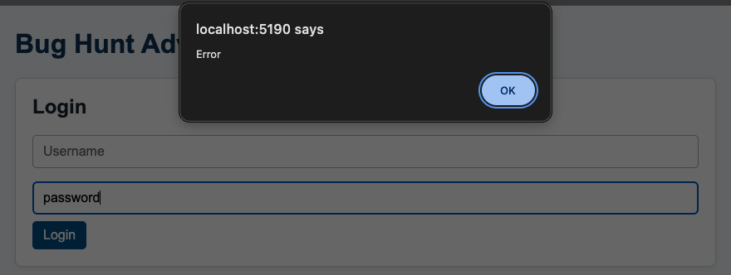

Field | Your Input
Bug ID | B-002
Test Case ID | T-003
Summary | Blank password shows a generic "Error" alert instead of "Password cannot be empty."
Steps to Reproduce | 1. Open the application.  2. Enter "admin" in Username.  3. Leave Password blank.  4. Select Login.
Expected Result | Access denied; "Password cannot be empty." is displayed.
Actual Result | Access denied; the Login form stays on screen. A browser alert shows only the text "Error".
Severity | Medium
Evidence | Window capture after selecting Login: Username shows "admin", Password is empty, and the browser alert at the top of the page reads only "Error".  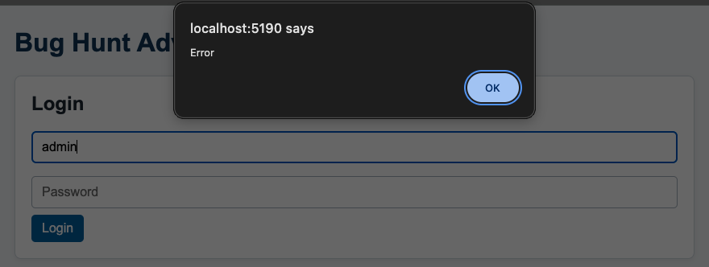
Field | Your Input
Bug ID | B-003
Test Case ID | T-004
Summary | Blank username and password show a generic "Error" alert instead of "Username and password cannot be empty."
Steps to Reproduce | 1. Open the application.  2. Leave Username blank.  3. Leave Password blank.  4. Select Login.
Expected Result | Access denied; "Username and password cannot be empty." is displayed.
Actual Result | Access denied; the Login form stays on screen. A browser alert shows only the text "Error".
Severity | Medium
Evidence | Window capture after selecting Login: both fields are empty, and the browser alert at the top of the page reads only "Error".  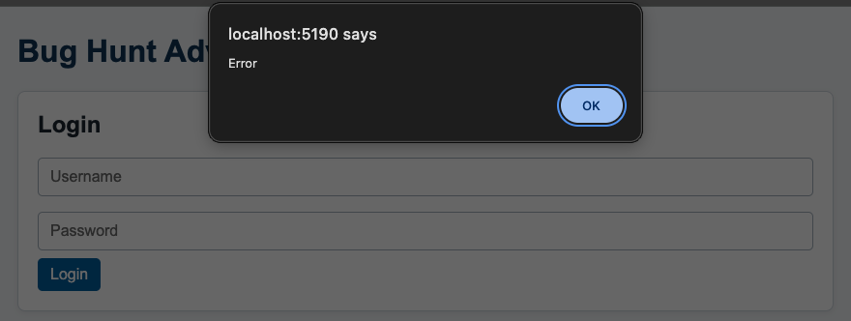
Field | Your Input
Bug ID | B-004
Test Case ID | T-005
Summary | Valid username with a wrong password shows "Error" instead of "Invalid credentials."
Steps to Reproduce | 1. Open the application.  2. Enter "admin" in Username.  3. Enter "wrongpass" in Password.  4. Select Login.
Expected Result | Access denied; "Invalid credentials." is displayed.
Actual Result | Access denied; the Login form stays on screen. A browser alert shows only the text "Error".
Severity | Low
Evidence | Window capture after selecting Login: Username shows "admin", Password shows "wrongpass", and the browser alert at the top of the page reads only "Error".  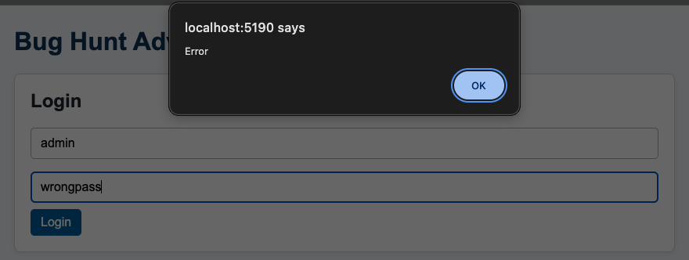
Field | Your Input
Bug ID | B-005
Test Case ID | T-006
Summary | Unknown username with the valid password shows "Error" instead of "Invalid credentials."
Steps to Reproduce | 1. Open the application.  2. Enter "user1" in Username.  3. Enter "password" in Password.  4. Select Login.
Expected Result | Access denied; "Invalid credentials." is displayed.
Actual Result | Access denied; the Login form stays on screen. A browser alert shows only the text "Error".
Severity | Low
Evidence | Window capture after selecting Login: Username shows "user1", Password shows "password", and the browser alert at the top of the page reads only "Error".  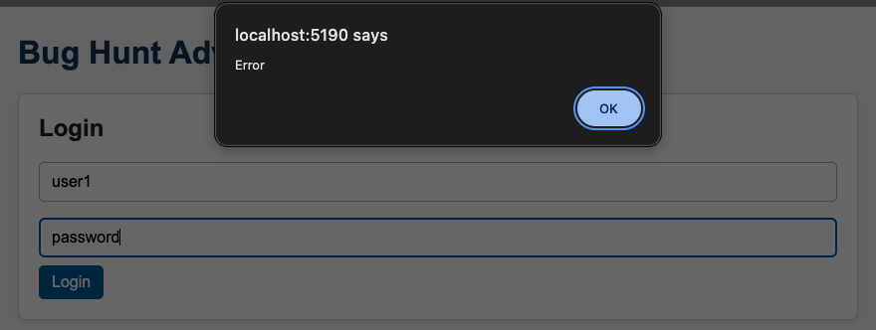
Field | Your Input
Bug ID | B-006
Test Case ID | T-007
Summary | Unknown username with a wrong password shows "Error" instead of "Invalid credentials."
Steps to Reproduce | 1. Open the application.  2. Enter "user1" in Username.  3. Enter "wrongpass" in Password.  4. Select Login.
Expected Result | Access denied; "Invalid credentials." is displayed.
Actual Result | Access denied; the Login form stays on screen. A browser alert shows only the text "Error".
Severity | Low
Evidence | Window capture after selecting Login: Username shows "user1", Password shows "wrongpass", and the browser alert at the top of the page reads only "Error".  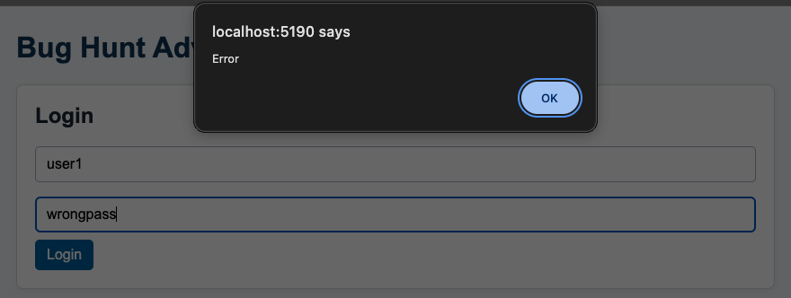
Field | Your Input
Bug ID | B-007
Test Case ID | T-024
Summary | Remove does not decrease the quantity of a product with quantity 3.
Steps to Reproduce | 1. Open the application.  2. Log in with admin / password.  3. Add Laptop three times; cart shows "Laptop (x3)".  4. Select Remove beside Laptop.
Expected Result | Laptop quantity decreases to 2.
Actual Result | Cart still shows "Laptop (x3)". Nothing changes.
Severity | Medium
Evidence | Shopping Cart section before and after selecting Remove beside Laptop. Both images show "Laptop (x3)". In the after image that Remove button is darker because the pointer is still on it from the click.  Before Remove  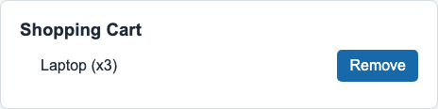  After Remove  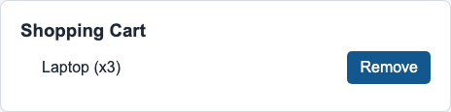
Field | Your Input
Bug ID | B-008
Test Case ID | T-025
Summary | Remove does not delete a product line whose quantity is 1.
Steps to Reproduce | 1. Open the application.  2. Log in with admin / password.  3. Add Laptop once and Smartphone once.  4. Select Remove beside Laptop.
Expected Result | Laptop line disappears; "Smartphone (x1)" remains.
Actual Result | Cart still shows "Laptop (x1)" and "Smartphone (x1)".
Severity | Medium
Evidence | Shopping Cart section before and after selecting Remove beside Laptop. Both images show "Laptop (x1)" and "Smartphone (x1)". In the after image that Remove button is darker because the pointer is still on it from the click.  Before Remove  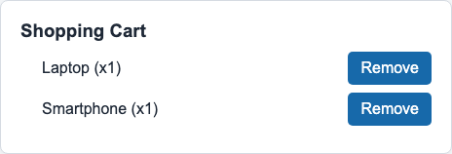  After Remove  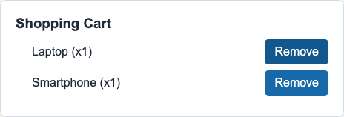
Field | Your Input
Bug ID | B-009
Test Case ID | T-026
Summary | Removing one product while others remain leaves the selected product in the cart.
Steps to Reproduce | 1. Open the application.  2. Log in with admin / password.  3. Add Laptop once and Smartphone twice.  4. Select Remove beside Laptop.
Expected Result | Laptop line disappears; "Smartphone (x2)" is unchanged.
Actual Result | Cart still shows "Laptop (x1)" and "Smartphone (x2)".
Severity | Medium
Evidence | Shopping Cart section before and after selecting Remove beside Laptop. Both images show "Laptop (x1)" and "Smartphone (x2)". In the after image that Remove button is darker because the pointer is still on it from the click.  Before Remove  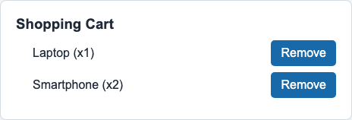  After Remove  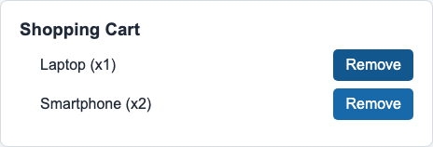
Field | Your Input
Bug ID | B-010
Test Case ID | T-027
Summary | Removing the last product does not empty the cart or show "Your cart is empty."
Steps to Reproduce | 1. Open the application.  2. Log in with admin / password.  3. Add Laptop once.  4. Select Remove beside Laptop.
Expected Result | Cart shows "Your cart is empty."
Actual Result | Cart still shows "Laptop (x1)"; the empty-cart message does not appear.
Severity | Medium
Evidence | Shopping Cart section before and after selecting Remove beside Laptop. Both images show "Laptop (x1)" and no "Your cart is empty." message. In the after image that Remove button is darker because the pointer is still on it from the click.  Before Remove  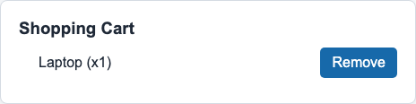  After Remove  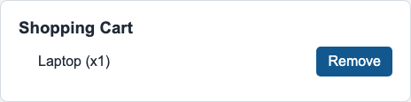
Field | Your Input
Bug ID | B-011
Test Case ID | T-028
Summary | Remove does not decrease the selected product when the cart has several products.
Steps to Reproduce | 1. Open the application.  2. Log in with admin / password.  3. Add Laptop twice and Smartphone three times.  4. Select Remove beside Smartphone.
Expected Result | Smartphone decreases to 2; Laptop stays at 2.
Actual Result | Cart still shows "Laptop (x2)" and "Smartphone (x3)". Smartphone is not decreased.
Severity | Medium
Evidence | Shopping Cart section before and after selecting Remove beside Smartphone. Both images show "Laptop (x2)" and "Smartphone (x3)". In the after image that Remove button is darker because the pointer is still on it from the click.  Before Remove  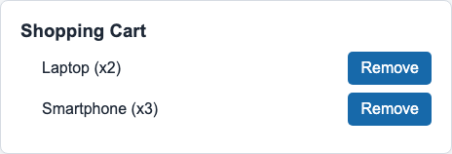  After Remove  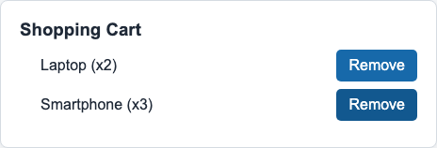
Bug reports B-001 to B-011 are in the tables above.

Part 3: Reflection and Key Takeaways

1. Most Valuable Bug
Which bug discovered had the highest Severity and why?
The highest severity found was Medium; no bug reached High because the app never crashed or lost data. The most valuable finding is the Remove from Cart defect, and B-010 in particular: removing the last product neither empties the cart nor shows "Your cart is empty." B-007 to B-011 together show that selecting Remove has no effect in any cart state, so an entire feature does not work and the user has no way to take an unwanted item out of the order. The login bugs B-001 to B-003 are also Medium, because the required-field messages are missing, but the login gate itself still works: every invalid attempt is denied and admin / password is accepted. B-004 to B-006 are Low, since access is correctly denied with a generic message and only the wording differs from "Invalid credentials."

2. Testing Perspective
During the activity, did you focus more on happy paths (testing what should work) or edge cases (testing boundaries and unexpected inputs)? Why is it important to explore both?
Most of my effort went into edge cases. Of the 28 test cases, six are happy paths (T-001, T-008, T-017 to T-019 and T-024), and the other 22 cover blank inputs, wrong credential combinations, case changes, partial and empty searches, repeated adds, mixed products, and boundary quantities. Both kinds were needed. For Login, the happy path passed and every defect appeared only in the edge cases, so happy-path testing alone would have reported login as working. For Remove from Cart, the happy path failed at once, and the edge cases showed that the defect affects every quantity and every cart state rather than one corner case. Search and Add to Cart passed both kinds, which is evidence that their business rules hold, not only their main flow.

3. Reporting Best Practices
What is the most critical component of a good bug report? (Is it the Summary, Steps to Reproduce, or Severity?) Explain your answer.
Steps to Reproduce is the most critical part of a good bug report. Every defect here depends on precise input or state: which login field is blank, which username and password pair is entered, or which products and quantities are in the cart before Remove is selected. Exact numbered steps let a developer rebuild that state in under a minute, see the same result, and confirm the fix afterwards. The Summary helps triage and the Severity sets priority, but a report that cannot be reproduced cannot be acted on.

